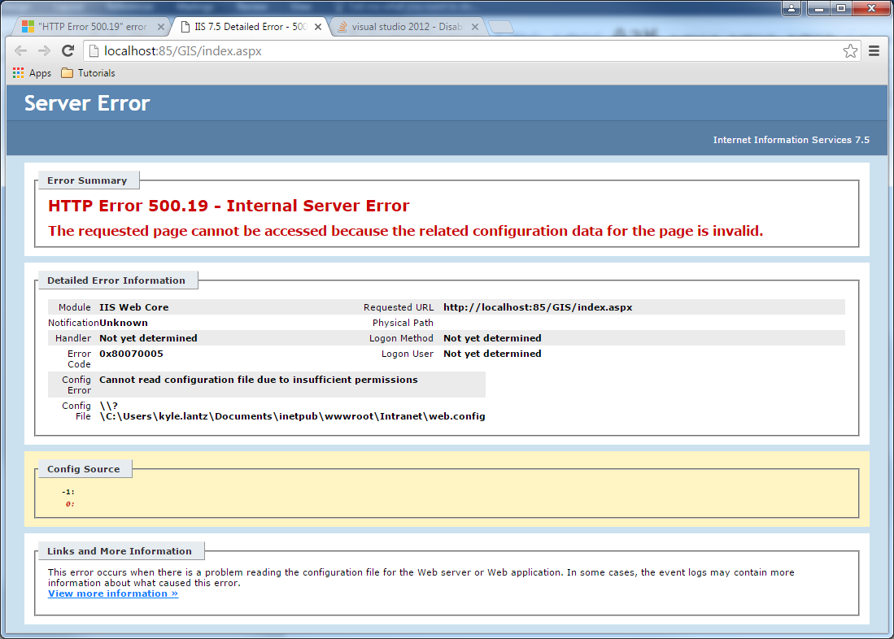

Grant the Read permission to the IIS_IUSRS group for the ApplicationHost.config file or for the Web.config file. To do this, follow these steps:

1. In Windows Explorer, locate the folder that contains the ApplicationHost.config file that is associated with the Web site, or locate the virtual directories or the application directories that contain the Web.config file that is associated with the Web site.  
   **Note**The Web.config file may not be in the virtual directories or the application directories in IIS. Even in this situation, you need to follow these steps.
2. Right-click the folder that contains the ApplicationHost.config file, or right-click the virtual or application directories that may contain the Web.config file.
3. Click **Properties**.
4. Click the **Security** tab, and then click **Edit**.
5. Click **Add**.
6. In the **Enter the object names to select** box, type **computername\IIS_IUSRS**, click **Check Names**, and then click **OK**.  
   **Note**Computername is a placeholder for the computer name.
7. Click to select the **Read** check box, and then click **OK**.

In the **Properties** dialog box for the folder, click **OK**.  
**Note**Make sure the folder's properties are inherited by the ApplicationHost.config and Web.config files so that IIS_IUSRS has the Read permission for those files.